SIMATS ENGINEERING
ASSESSMENT TOOL 2: Pseudocode Writing Task (Algorithm Design)
COURSE NAME: COMPUTER VISION COURSE CODE: ITA0515 Slot B
COURSE OUTCOME COVERED
CO5: Develop computer vision applications using OpenCV for performing recognition and analysis on images and videos. (BTL 6)
Assessment Tool Weightage: 20%
QUESTIONS:5 Total Marks 20 Duration :60 Minutes Annexure A
Pseudocode Writing Task (Algorithm Design)
Code of Conduct:
I _K Sreelatha(192425248)__ (Name / Reg No) certify that this submission is my original work and that I have adhered to the guidelines specified for this assessment. IL= understand that any violation of academic integrity rules will result in disciplinary action.
Signature of the student: Sree K
Rubrics for Evaluation
Criteria | Weightage  (%) | Level 4 (Exemplary) | Level 3 (Proficient) | Level 2  (Developing) | Level 1  (Beginning) | Marks(100)
Problem  Understanding | 20% | Identifies all inputs,  outputs, constraints  accurately | Minor missing  elements | Partial  understanding | Incorrect  interpretation
Algorithm  Design | 30% | Complete, correct, and logically sound solution | Minor logical  gaps | Partially correct logic | Incorrect  approach
Use of Control Structures | 20% | Efficient and  appropriate use of  loops, conditions,  functions/modules | Minor  inefficiencies | Limited or  basic usage | Incorrect or  missing  constructs
Pseudocode  Structure | 10% | Well-structured, clear, consistent format, easy to follow | Mostly clear with minor issues | Difficult to  follow in parts | Poorly  structured and unclear
Completeness | 20% | Handles all cases;  optimized approach | Handles most  cases;  reasonable  efficiency | Handles basic cases only | Incomplete or  inefficient

Pseudocode Writing Tasks: Design a clear and structured pseudocode for the given problem by organizing the solution into logical stages of a computer vision pipeline. Ensure proper use of control flow, modular steps, and justification of key operations to satisfy the given constraints.
1.Real-Time Object Detection Pipeline
A system must:
A. Capture video frames
B. Detect objects using a trained model
C. Draw bounding boxes and labels
D. Display results in real time
Constraints:
• Must process frames efficiently
• Handle multiple objects
Write detailed pseudocode with modular steps for detection, visualization, and efficient looping.
2. Image Difference Detection System
A system must:
A. Read two images
B. Compare them
C. Highlight differences
Constraints:
• Handle noise
• Ensure accurate difference detection
Write pseudocode including preprocessing, comparison logic, and visualization.
3. Video Frame Extraction System
A system must:
A. Read video input
B. Extract frames at fixed intervals
C. Save selected frames
Constraints:
• Efficient storage
• Avoid redundant frames
Write structured pseudocode for frame selection and saving logic.
4. Background Subtraction Pipeline
A surveillance system must:
A. Read video stream
B. Separate foreground from background
C. Highlight moving objects
Constraints:
• Handle dynamic background
• Reduce noise
Write pseudocode including background modeling, subtraction, filtering, and display.
5. Edge Detection Pipeline for Real-Time Video
A system must:
A. Capture video frames
B. Apply edge detection
C. Display results
Constraints:
• Real-time processing
• Maintain clarity of edges
Write pseudocode with preprocessing, edge detection, and visualization modules.

1. Real-Time Object Detection Pipeline
Aim
To design a real-time object detection pipeline that captures video frames, detects multiple objects using a trained model, draws bounding boxes and labels, and displays the results efficiently.
Pseudocode
BEGIN

1. Load the trained object detection model.
2. Initialize the video camera.
3. Set the required confidence threshold.
4. WHILE video is running:
a. Capture a video frame.
b. If frame is not available, EXIT loop.
c. Resize the frame if required for faster processing.
d. Send the frame to the object detection model.
e. For every detected object:
i. Obtain bounding box coordinates.
ii. Obtain object class and confidence.
iii. If confidence is above threshold:
- Draw bounding box.
- Display object label and confidence.
f. Display the processed frame.
g. If exit key is pressed, EXIT loop.
5. Release the video camera.
6. Close all windows.

END

Output
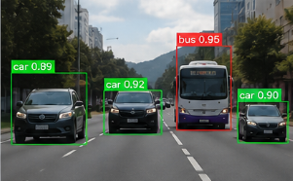
Result
The real-time object detection pipeline successfully detects multiple objects from video frames and displays their bounding boxes, class labels, and confidence values. Efficient frame processing and confidence filtering help maintain real-time performance.

2. Image Difference Detection System
Aim
To design an image difference detection system that compares two images, identifies changes between them, removes noise, and highlights the detected differences.
Pseudocode
BEGIN
1. Read Image A.
2. Read Image B.
3. Resize both images to the same dimensions if required.
4. Convert both images into grayscale.
5. Apply Gaussian filtering to reduce noise.
6. Calculate the absolute difference between Image A and Image B.
7. Apply thresholding to identify significant differences.
8. Apply morphological operations to remove small noise.
9. Find contours of the detected difference regions.
10. Draw bounding contours around the differences.
11. Display the original images and difference output.
12. Stop.

END
Output
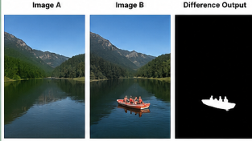
Result
The image difference detection system successfully identifies and highlights changes between two images. Noise reduction, thresholding, and morphological operations improve the accuracy of difference detection and reduce unwanted false differences.

3. Video Frame Extraction System
Aim
To design a video frame extraction system that reads a video, extracts frames at fixed intervals, and saves only the required frames to reduce redundant storage.
Pseudocode
BEGIN
1. Read the input video.
2. Set the frame extraction interval N.
3. Initialize frame_count = 0.
4. Initialize saved_count = 0.
5. WHILE video is available:
a. Read the next frame.
b. If frame is not available, EXIT loop.
c. Check whether frame_count MOD N = 0.
d. If TRUE:
i. Save the current frame.
ii. Increase saved_count by 1.
e. Increase frame_count by 1.
6. Release the video.
7. Display the number of frames saved.
8. Stop.

END
Output
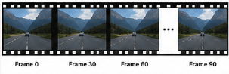
Result
The video frame extraction system successfully selects and saves frames at fixed intervals. By avoiding the storage of every frame, the system reduces redundant data and uses storage space efficiently.

4. Background Subtraction Pipeline
Aim
To design a background subtraction pipeline that separates moving foreground objects from a video background, reduces noise, and highlights detected moving objects.
Pseudocode
BEGIN

1. Initialize the video stream.
2. Initialize a background subtraction model.
3. WHILE video is running:
a. Capture the current frame.
b. If frame is not available, EXIT loop.
c. Apply background subtraction.
d. Generate the foreground mask.
e. Apply thresholding to remove weak detections.
f. Apply morphological opening to remove noise.
g. Apply morphological closing to fill small gaps.
h. Find contours of foreground objects.
i. Ignore very small contours.
j. Draw bounding boxes around detected objects.
k. Display the original frame and foreground mask.
l. If exit key is pressed, EXIT loop.
4. Release the video stream.
5. Close all windows.

END
Output
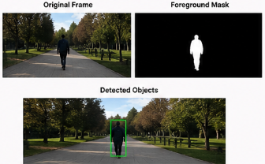
Result
The background subtraction pipeline successfully separates moving objects from the background and highlights the foreground regions. Noise reduction and morphological operations improve the detection of moving objects in dynamic environments.

5. Edge Detection Pipeline for Real-Time Video
Aim
To design a real-time edge detection pipeline that captures video frames, preprocesses them, detects important edges using the Canny operator, and displays the edge information clearly.
Pseudocode
BEGIN

1. Initialize the video camera.
2. WHILE video is running:
a. Capture a video frame.
b. If frame is not available, EXIT loop.
c. Resize the frame if necessary.
d. Convert the frame into grayscale.
e. Apply Gaussian blur to reduce noise.
f. Apply Canny edge detection.
g. Display the detected edge image.
h. If exit key is pressed, EXIT loop.
3. Release the camera.
4. Close all windows.

END
Output
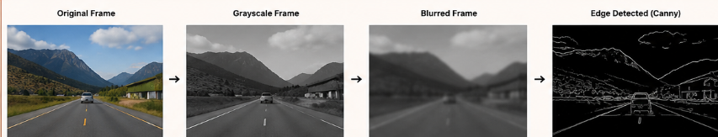Result
The edge detection pipeline successfully detects significant edges in real-time video. Grayscale conversion and Gaussian filtering reduce unnecessary information and noise, while the Canny operator produces clear object boundaries with efficient processing.

